APPENDIX A
Mutual Agreement Form for Co-Authorship
(Adopted from Philippine Association of Institutions for Research (PAIR), Inc.)

WE, the researcher, and research adviser/consultant, have worked together in a capstone project from January 2024 to August 2024.
WE have used various forms of contact during the thesis work such as Microsoft Teams and Facebook.
WE agree that
• the academic partnership leads to publication of the manuscript with the research consultant as the author and the researcher, the primary author.
• the paper be presented in public forum by the researcher if available at such an opportunity or by the research adviser/consultant if the researcher is no longer around.
• only the name of the oral presenter shall be submitted to the Conference organizer.
WE agree to dress formally and prepare adequately for the formal oral presentation in both the oral defense panel and the public presentations.
Signed this 27th of July in the year of our Lord 2024 in Bacolod City, Philippines.
THALEA PRINCE P. BALADHAY  Researcher | ELMER T. HARO, Ph.D.  Adviser
MARVIN JOMEL O. FELIPE  Researcher | REINHARDT D. FIRMEZA, MIT Candidate  Witness
BERNARD ANTON J. MILLARO
Researcher
APPENDIX B
HydroSense Concept Paper.

Project Concept Title | HydroSense |  | Technical Consultant
Main Proponent | Millaro, Bernard Anton J. |  | Elmer T. Haro, Ph.D.
Collaborators | Felipe, Marvin Jomel O. | Team name | Consultant’s Appointment Status
Collaborators | Baladhay, Thalea Prince P. | Stealthy Kitten | ☒In Agreement  ☐To be Approached
Rationale of the Concept Paper
Clean water is essential to life, as hydration is the most basic function of water, necessary to keep the body of a living organism hydrated. It is important to preserve and sustain the availability of water for our bodies that rely on water for digestion, metabolism, transportation of nutrients, and temperature regulation [PM2024]. One of the Sustainable Development Goals (SDGs) is the SDG 6, clean water and sanitation adopted by the United Nations (UN). SDG 6 clean water and sanitation goal is to ensure availability and sustainable management of water sanitation for all and achieve universal and equitable access to safe and affordable drinking water for all. [OD2021]
HydroSense is not just a technological advancement. It is a solution for communities grappling with waterborne diseases due to not having access to clean water. It goes beyond mere detection. It acts as a driving force for data-driven decision-making. It provides legitimate articles and guides about hydrology based on credible sources, offering guidance on how to manage water. These resources serve as references for understanding water and ways to manage it, including purification methods. Through seamless integration, our software – hardware integration application empowers communities to proactively monitor and manage their water resources, mitigating risks and safeguarding public health.

Features and Functions
HydroSense, powered by Arduino and essential sensors, offers real-time water quality monitoring with TDS, turbidity, temperature, and pH data. Its user-friendly web app provides actionable insights, purification recommendations, and hydrology resources for effective water management.
- Contaminant Detection
HydroSense's sensors for TDS, turbidity, temperature, and pH provide real-time water quality data, enabling accurate assessment of harmful substances. This empowers users with tailored purification recommendations, ensuring clean water access and proactive quality management.

- Data Visualization
HydroSense visualizes water quality through real-time graphs and historical trends for TDS, turbidity, temperature, and pH. Users can view current values, track changes over time, and download data in CSV format for analysis or sharing, enhancing water quality monitoring and management.

- Water Quality Recommendation
HydroSense's recommendation system analyzes sensor data to provide tailored water purification advice, helping users address contaminants effectively and maintain access to clean water.

- Hydrology Resources
HydroSense offers resources on water quality, safety, and purification, featuring guides on monitoring, health impacts of contaminants, and best practices. Content from trusted sources like WHO and CDC ensures accuracy and relevance.
Technical Requirements
Arduino
TDS sensor
pH sensor
Turbidity sensor
Water temperature sensor
Bluetooth or Wi-Fi for wireless data transfer
Database for storing data of the sensors
Real-time graphing of data framework
Project Usability / Justification of Benefits
Enable users to monitor TDS in water in real-time for early detection of pollution or contaminants.
A tool for users to ensure safety in their water supply or sources

Anticipated Challenges
Calibrating TDS
Data transmission security between devices

References
https://www.aquasana.com/info/tds-meter-what-is-it-and-do-you-need-it-pd.html

APPENDIX C
PERT Table.

CODE | ACTIVITIES | PREDECESSOR | DURATION  (in week/s)
A | Identify the project requirements | - | 1
B | Identify projects scope | A | 1
C | Identify projects target users | A | 1
D | Identify projects hardware and software specification | A | 1
E | Procure hardware components | D | 3
F | Search for related apps | B | 1
G | Analysis of existing similar apps | F | 1
H | Conduct an interview | C | 2
I | Analyze gathered data | G, H | 1
J | Make a draft of the web pages | D | 1
K | Evaluate the functionalities and design | J, I | 1
L | Develop hardware prototype | E | 4
M | Website front-end coding | K | 4
N | Website backend coding | K | 4
O | Finalize hardware project | L, M, N | 2
P | Integration of Web and Hardware | O | 2
Q | Recognize and fix errors | P | 1
R | Test execution | Q | 1
S | User acceptance testing | R | 1
T | Recognize and fix errors | S | 2
U | General Release | T | 1

APPENDIX D
PERT Diagram.

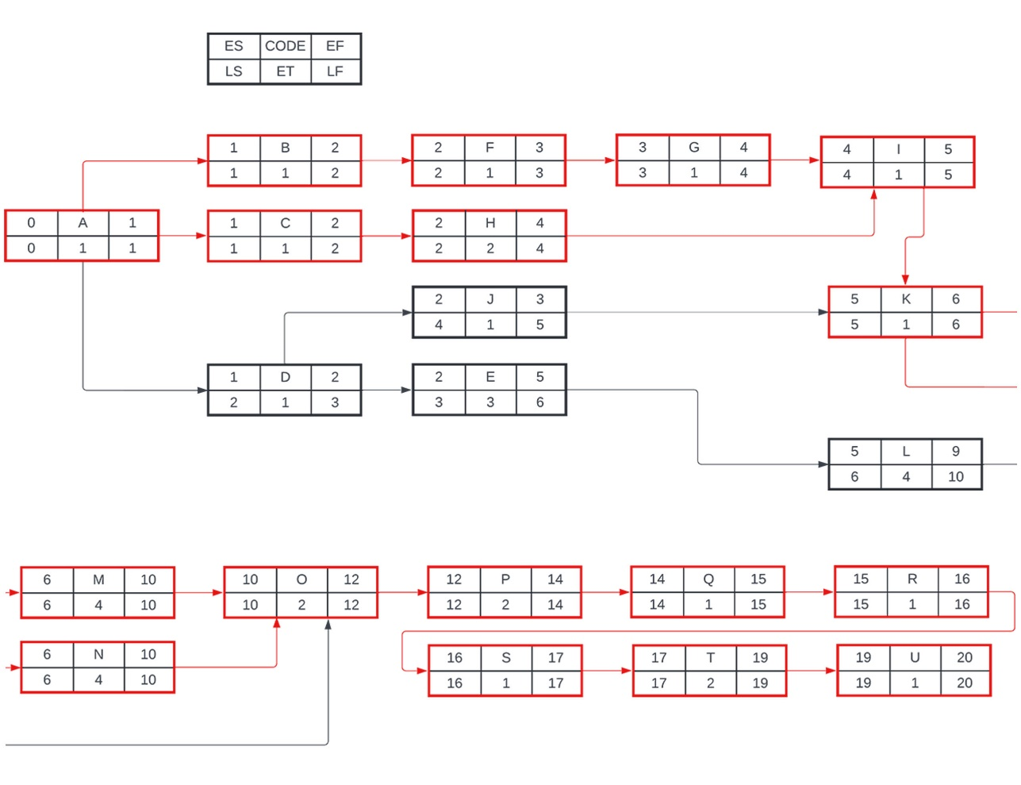

APPENDIX E
Gantt Chart.

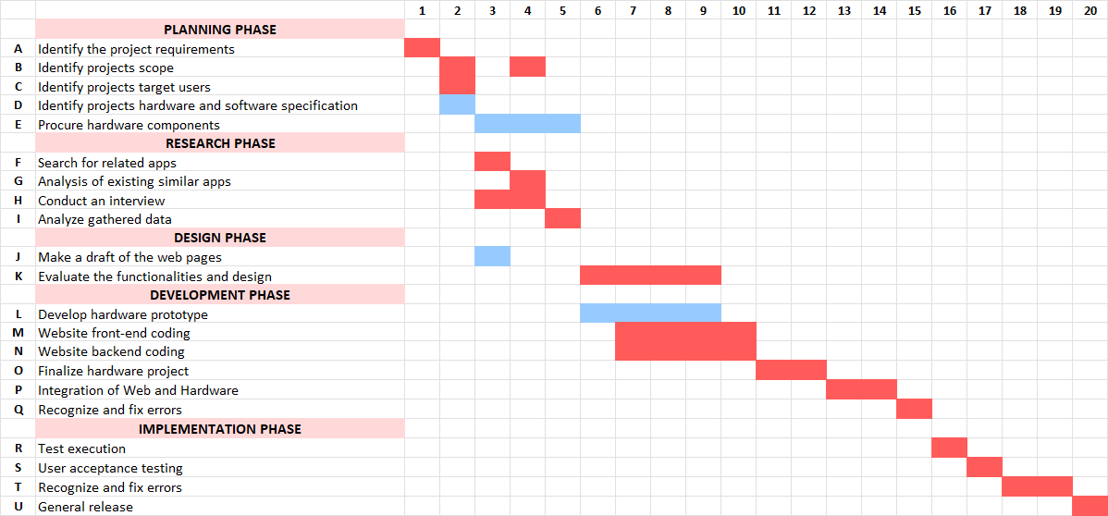

APPENDIX F
Project Cost.

Project Cost
Hardware Cost | Product | Price
 | Arduino ESP32-WROOM-32D | ₱ 179.00
 | OLED Screen 0.96in | ₱ 78.00
 | Temp Sensor 1SET | ₱ 91.00
 | Turbidity Sensor | ₱ 314.00
 | pH 0-14 module | ₱ 459.00
 | ESP32 Adapter 38P | ₱ 90.00
 | Micro SD Card storage module | ₱ 23.00
 | Dupont Jumper Wire | ₱ 116.00
 | TDS Sensor | ₱ 226.00
Total Hardware Cost: |  | ₱ 1,576.00
Operation Cost | Product | Price
 | 3D Printer | ₱ 2,100.00
 | Filaments | ₱ 2,800.00
Total Operation Cost: |  | ₱ 4,900.00
Total Project Cost: |  | ₱ 6,476.00

APPENDIX G
Minutes of the Capstone Project Proposal Defense.

May 31, 2024 | 6:30 pm – 8:00 pm
College of Information Technology
University of Negros Occidental – Recoletos

Project Proposal Title | HydroSense
Group Members | Thalea Prince Baladhay  Marvin Jomel Felipe  Bernard Anton Millaro
Panel Members | Reinhardt D. Firmeza  Elmer T. Haro, Ph.D.  Reymund L. Sabay
Interpellators | Kristian Franco  Christian Javier  Alfie Mondia

- The conference started with a prayer led by Marvin Felipe.
- The group members were introduced by Marvin Felipe.
- The oral presentation was delivered by Thalea Prince Baladhay, Marvin Jomel Felipe and Bernard Anton Millaro.
- After the presentation, the following are the suggestions, recommendations of the interpellators and the panel members:

Chapter/Section | Recommendations/Suggestion | Proponent | Action Taken | Reference / Proof
System Features and Functionalities | Issues in storage limitation | Reinhardt D. Firmeza | Added to recommendations | Hardware
Product Prototype/Interface | Overly loaded System | Reinhardt D. Firmeza | Revised the interface for the overly loaded system. | Page 63
Product Prototype/Interface | Methods and legends on reports | Elmer T. Haro | Added to the interface in data insights | Page 64
Product Prototype/Interface | Issues on the layout of the interface | Alfie Mondia | Change the layout of the interface | Page 63 to Page 70
References | Consult experts on water quality | Reymund L. Sabay | Added to recommendations
References | Availability of the websites for user | Reymund L. Sabay | Added to the hydrological resources | Page 67

5. After the deliberation of the interpellators and panel members, the proposal is considered accepted with revisions in the documentation and in the prototype.

6. The conference ended 8:10 PM.

Transcribed by : Thalea Prince P. Baladhay
Noted by : Elmer T. Haro, Ph.D.
APPENDIX H
Product Logo.
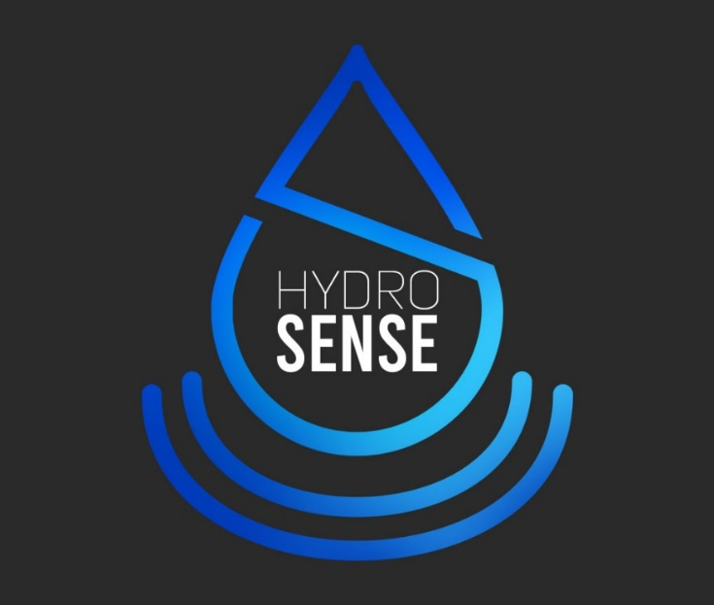

The proponents choose the colors and elements, which have an interpretation that reflects the application purpose. Each color symbolizes the application values and interests, as well as to draw attention of users and be more recognizable. Blue gradient emphasizes the water and cleanliness, as blue recognizes security and creativity since it produces a slow physiological response. However, interpretations of blue can be paradoxical, as it's also associated with calmness and serenity due to its connection with bodies of water.
The logo of the application incorporates various elements and illustrations, each symbolizing a key aspect of the project's purpose. The water droplet shape is designed to resemble the letter "S," emphasizing the "sense" in HydroSense product. Additionally, the two radio waves at the bottom interpret the product's connectivity and communication capabilities, illustrating its seamless data gathering and transmission functionalities.

APPENDIX I
Group Logo.


The colors and elements that comprise the team's logo indicate their characteristics and expertise. The grey gradient symbolized formality and sophistication with elegance and simplicity. The team's mascot, a kitten, represents playfulness and the importance of learning through play to develop adult skills.

APPENDIX J
Product Poster.
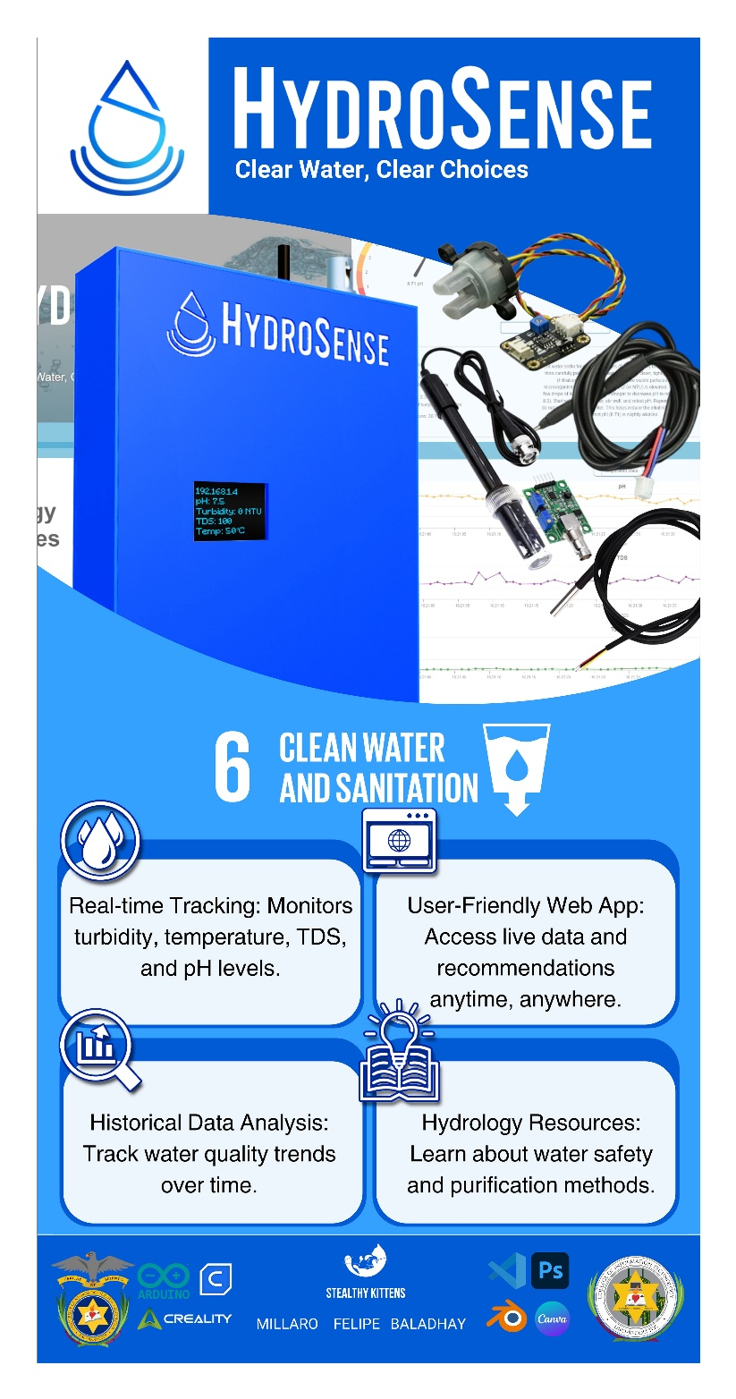
APPENDIX K
Product Packaging.

Front
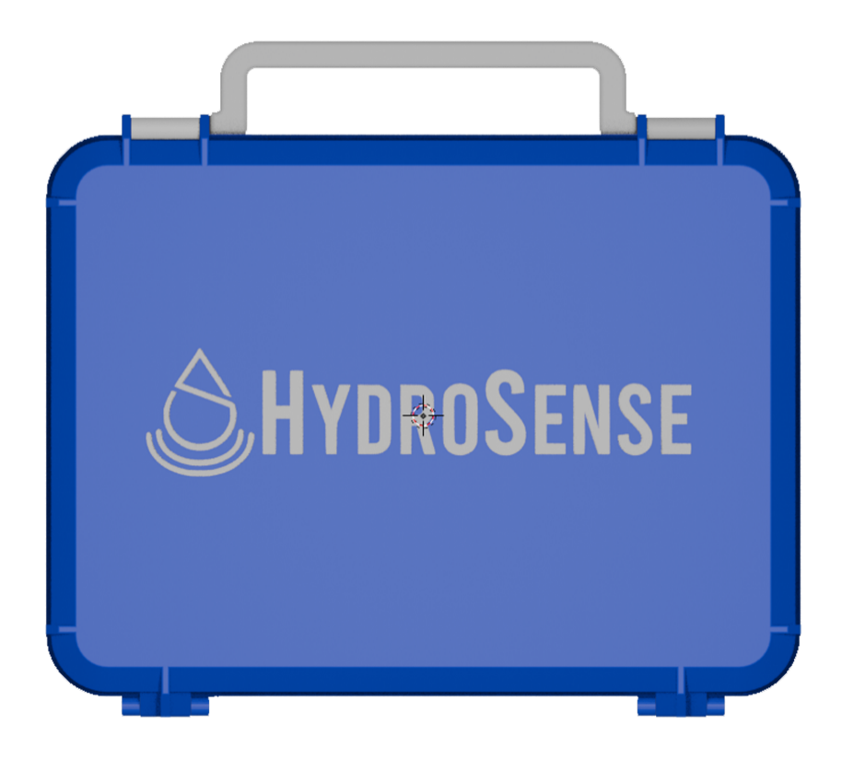

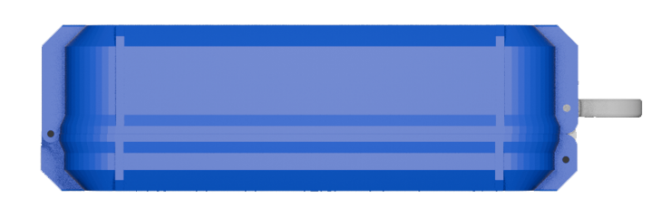
Side (right and left)

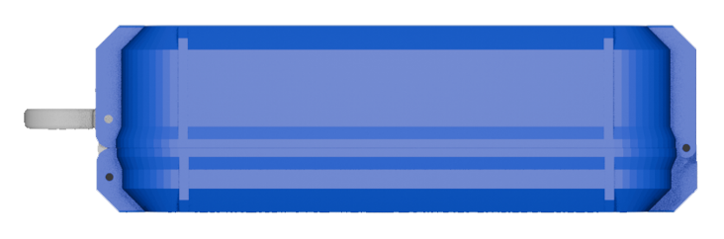

Back

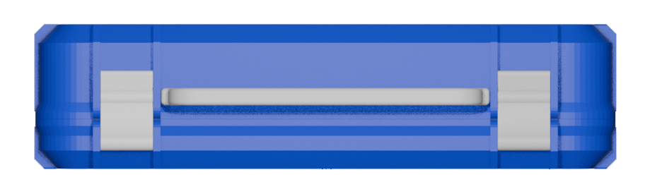
Top Side


Bottom

APPENDIX L
Minutes of the Capstone Project Final Defense.

August 8, 2024 | 4:30 pm – 6:30 pm
College of Information Technology
University of Negros Occidental – Recoletos

Project Proposal Title | HydroSense
Group Members | Thalea Prince Baladhay  Marvin Jomel Felipe  Bernard Anton Millaro
Panel Members | Reinhardt D. Firmeza  Elmer T. Haro, Ph.D.  Reymund L. Sabay
Interpellators | Alexander Nicole Bravo  Christian Javier  Alijah Mckale Rodis

- The conference started with a prayer led by Marvin Felipe.
- The group members were introduced by Marvin Felipe.
- The oral presentation was delivered by Thalea Prince Baladhay, Marvin Jomel Felipe and Bernard Anton Millaro.
- After the presentation, the following are the suggestions, recommendations of the interpellators and the panel members:

Chapter/Section | Recommendations/Suggestion | Proponent | Action Taken | Reference / Proof
Title and Front Matters
Introduction and System Decomposition | Technical details of the hardware in simplified version | Alijah Mckale V. Rodis | Simplified technical details of the hardware ensure easy understanding and accessibility for users. | Page 20
Product Prototype/Interface | Improve the case of sensors | Christian Javier | The sensor casing was improved for enhanced durability and protection. | Hardware
Product Prototype/Interface | Adjust the size and design of the hardware | Alexander Nicole Bravo | The hardware was resized and redesigned for improved usability and portability. | Hardware
Product Prototype/Interface | Hydrology Resources properly cited | Reinhardt D. Firmeza | Properly cited hydrology resources ensure credibility and accuracy of the provided information. | Page 67
Product Prototype/Interface | Reports and recommendations | Reymund L. Sabay | Reports and recommendations provide users with clear insights and actionable steps for improving water quality. | Page 63
Product Prototype/Interface | Presentations of graphs | Alijah Mckale V. Rodis | Graphs are presented in an intuitive format, enabling easy interpretation of water quality data. | Page 64, Page 65
Appendices | Improve the promotional video and product packaging | Elmer T. Haro, Ph.D. | Enhancements were made to the promotional video and product packaging to better showcase features and attract users. | Page 172, Page 173
References | Ensure that the citation is properly specified in the references section | Reinhardt D. Firmeza | Rephrased the sentence for clarity and grammatical correctness. | Page 203

5. After the deliberation of the interpellators and panel members, the proposal is considered accepted with revisions in the documentation and in the prototype.

6. The conference ended 6:00 PM.

Transcribed by : Thalea Prince P. Baladhay
Noted by : Elmer T. Haro, Ph.D.
APPENDIX M
Internal Quality Measurement Results in Software.

Hydrology Resources
Understandability

X = A / B
A = Number of UI functions whose purpose is understood by user.
B = Total number of interface functions.
Functions | Status
View Hydrology Resources Topics | Understood
View Hydrology Resources Articles | Understood
View Hydrology Resources Guides | Understood
View Hydrology Resources Video | Understood
Search Bar | Understood
Topic Sorting | Understood
Start Logging button | Not Understood
Computations
(6 / 7) * 100 = 85.71%

TOTAL | 85.71%
Learnability

X = 1 - A / B
A = Number of incomplete help topics.
B = Total number of help topics.
Functions | Status
View Hydrology Resources Articles | Help Topics Available
View Hydrology Resources Guides | Help Topics Available
View Hydrology Resources Videos | Help Topics Available
Computations
(3 / 3) * 100 = 100.00%

TOTAL | 100.00%
Operability

X = A / B
A = Number of customizable functions.
B = Total number of functions requiring customization.
Functions | Status
Customizable Search Filters | Completed
Computations
(1 / 1) * 100 = 100.00%
TOTAL | 100.00%
Attractiveness

X = A / B
A = Number of customized interface elements.
B = Total number of interface elements.
Functions | Status
Responsive Web Interface | Implemented
Cohesive Color Scheme | Implemented
Custom Icons and Graphics | Implemented
Computations
(3 / 3) * 100 = 100.00%

TOTAL | 100.00%
ISO/IEC-9126 Compliance

X = A / B
A = Number of correctly implemented compliance items.
B = Total number of compliance items.
Functions | Status
Compliance with WHO Content Standards | Implemented Correctly
Compliance with FDA Content Standards | Implemented Correctly
Compliance with CDC Content Standards | Implemented Correctly
Regularly Updated Content | Delayed
Computations
(3 / 4) * 100 = 75.00%

TOTAL | 75.00%

Contaminant Detection
Accuracy

X = 1 - A / B
A = Number of data items with incorrect precision.
B = Total number of data items requiring precision.
Functions | Status
Water pH Level Detection | Accurate
Water TDS Level Detection | Accurate
Water Turbidity Level Detection | Accurate
Water Temperature Level Detection | Accurate
Computations
(4 / 4) * 100 = 100.00%

TOTAL | 100.00%
Interoperability

X = A / B
A = Number of correctly implemented data formats.
B = Total number of required data formats.
Functions | Status
JSON Data Format Compatibility | Implemented
HTTP Communication | Implemented
CSV format in saving data
Computations
(3 / 3) * 100 = 100.00%

TOTAL | 100.00%
ISO/IEC-9126 Compliance

X = A / B
A = Number of correctly implemented compliance items.
B = Total number of compliance items.
Functions | Status
Intuitive User Interface | Implemented Correctly
Error Handling | Implemented Correctly
Icons for each level | Not Implemented Correctly
pH level gauge | Implemented Correctly
TDS level gauge | Implemented Correctly
Turbidity level gauge | Implemented Correctly
Water temperature gauge | Implemented Correctly
Computations
(6 / 7) * 100 = 85.71%

TOTAL | 85.71%

Data Visualization
Resource Utilization

X = A / B
A = Number of I/O error messages.
B = Number of lines of code related to system calls.
Functions | Status
I/O Error Handling | No Errors
System Calls for Data Loading | No Errors
Memory overflow when refreshed | Error
Data Export Operations | No Errors
Computations
(3 / 4) * 100 = 75.00%

TOTAL | 75.00%
Time Behavior

X = A / B
A = Number of time delays.
B = Total number of data streams.
Functions | Status
Real-time Data Stream 1 (pH Sensor) | No Delays
Real-time Data Stream 2 (TDS Sensor) | No Delays
Real-time Data Stream 3 (Turbidity Sensor) | No Delays
Real-time Data Stream 4 (Temperature Sensor) | No Delays
Group/Ungroup Toggle for Line Chart | No Delays
Computations
(5 / 5) * 100 = 100.00%

TOTAL | 100.00%
ISO/IEC-9126 Compliance

X = A / B
A = Number of correctly implemented compliance items.
B = Total number of compliance items.
Functions | Status
Compliance with data visualization performance standards | Implemented Correctly
Compliance with real-time data monitoring requirements | Implemented Correctly
CSV export functionality compliance (Data Integrity) | Implemented Correctly
Computations
(3 / 3) * 100 = 100.00%

TOTAL | 100.00%
Data Handling and Visualization

X = A / B
A = Number of data types processed and visualized correctly
B = Total number of data types
Functions | Status
pH sensor data visualization | Correct
TDS sensor data visualization | Correct
Turbidity sensor data visualization | Correct
Temperature sensor data visualization | Correct
CSV export for historical data analysis | Correct
Computations
(6 / 6) * 100 = 100.00%

TOTAL | 100.00%
User Interaction and Customization

X = A / B
A = Number of customizable or interactive features implemented
B = Total required customizable features
Functions | Status
Customizable chart views (grouping/ungrouping sensors) | Correct
Historical data download in CSV format | Correct
Turbidity sensor data visualization | Correct
Ability to zoom and filter data for specific timeframes | Correct
Computations
(4 / 4) * 100 = 100.00%

TOTAL | 100.00%
Real-time Capability

X = A / B
A = Number of real-time updates provided
B = Total number of required updates
Functions | Status
Real-time updates for pH sensor data | Real-time
Real-time updates for TDS sensor data | Real-time
Real-time updates for turbidity sensor data | Real-time
Real-time updates for temperature sensor data | Real-time
Computations
(4 / 4) * 100 = 100.00%

TOTAL | 100.00%

Water Quality Recommendation
Understandability

X = A / B
A = Number of UI functions whose purpose is understood by user.
B = Total number of interface functions.
Functions | Status
pH level display | Understood by User
Turbidity level display | Understood by User
TDS level display | Understood by User
Water temperature display | Understood by User
Water Quality Recommendation Based on Sensor Data | Understood by User
Computations
(6 / 6) * 100 = 100.00%

TOTAL | 100.00%
Learnability

X = 1 - A / B
A = Number of incomplete help topics.
B = Total number of help topics.
Functions | Status
Explanation of TDS levels and health impacts | Comprehensive
Explanation of pH levels and health impacts | Comprehensive
Explanation of turbidity and its health risks | Comprehensive
Explanation of water temperature and its significance | Comprehensive
Health Impact of Unsafe Water | Comprehensive
Water purification method recommendations | Comprehensive
Computations
(6 / 6) * 100 = 100.00%

TOTAL | 100.00%
Operability

X = A / B
A = Number of customizable functions.
B = Total number of functions requiring customization.
Functions | Status
Customizable sensors update time | Not Completed
Customizable water quality thresholds (safe TDS range) | Implemented
Customizable water quality thresholds (safe pH range) | Implemented
Customizable water quality thresholds (safe Turbidity range) | Implemented
Customizable water quality thresholds (Temperature range) | Implemented
Computations
(4 / 5) * 100 = 100.00%

TOTAL | 100.00%
ISO/IEC-9126 Compliance

X = A / B
A = Number of correctly implemented compliance items.
B = Total number of compliance items.
Functions | Status
Compliance with real-time monitoring requirements | Complaint
Compliance with water safety standards (WHO) | Complaint
Computations
(2 / 2) * 100 = 100.00%

TOTAL | 100.00%

APPENDIX N
Internal Quality Measurement Results in Hardware.

IoT system trustworthiness characteristics
Availability

X = A / B
A = Number of unplanned hardware downtimes.
B = Total number of operational instances.
Functions | Status
pH sensor | Operational
pH sensor interface board | Operational
TDS sensor | Operational
TDs sensor interface board | Operational
Turbidity sensor | Operational
Turbidity sensor interface board | Operational
Temperature sensor | Operational
Arduino Uno | Operational
ESP32 | Operational
Computations
(1 – 0 / 9) * 100 = 100.00%

TOTAL | 100.00%
Confidentiality

X = A / B
A = Number of secure transmissions.
B = Total number of data transmissions.
Functions | Status
Wi-Fi data encryption | Secure
pH sensor data encryption | Secure
TDS sensor data encryption | Secure
Turbidity sensor data encryption | Secure
Temperature sensor data encryption | Secure
Single user can login per device | Not Secure
Computations
(5 / 6) * 100 = 83.33%

TOTAL | 83.33%
Integrity

X = A / B
A = Number of correctly transmitted data packets.
B = Total number of transmitted packets.
Functions | Status
pH sensor data integrity | Correct
TDS sensor data integrity | Correct
Turbidity sensor data integrity | Correct
Temperature sensor data integrity | Correct
Saved data integrity | Correct
Computations
(4 / 4) * 100 = 100.00%

TOTAL | 100.00%
Reliability

X = A / B
A = Number of consistent sensor readings.
B = Total number of sensor readings.
Functions | Status
pH sensor consistency | Consistent
TDS sensor consistency | Consistent
Turbidity sensor consistency | Consistent
Temperature sensor consistency | Consistent
Computations
(4 / 4) * 100 = 100.00%

TOTAL | 100.00%
Resilience

X = A / B
A = Number of successful recoveries from system failures.
B = Total number of system failures.
Functions | Status
Recovery from network disruption | Successful
Recovery from power failure | Successful
Recovery from sensor malfunction | Successful
Computations
(3 / 3) * 100 = 100.00%

TOTAL | 100.00%
Safety

X = A / B
A = Number of safe operational instances.
B = Total number of operational instances.
Functions | Status
Safe sensor operation during data handling | Safe
Electrical safety for hardware components | Safe
Computations
(2 / 2) * 100 = 100.00%

TOTAL | 100.00%

IoT system architecture characteristics
Heterogeneity

X = A / B
A = Number of successfully integrated sensor types.
B = Total number of sensor types.
Functions | Status
pH Sensor Integration | Successful
TDS Sensor Integration | Successful
Turbidity Sensor Integration | Successful
Temperature Sensor Integration | Successful
Computations
(4 / 4) * 100 = 100.00%

TOTAL | 100.00%
Modularity

X = A / B
A = Number of replaceable modular components.
B = Total number of modular components.
Functions | Status
pH Sensor | Replaceable
TDS Sensor | Replaceable
Turbidity Sensor | Replaceable
Temperature Sensor | Non-Replaceable
Computations
(3 / 4) * 100 = 75.00%

TOTAL | 75.00%
Network Connectivity

X = A / B
A = Number of successful network connections.
B = Total number of connection attempts.
Functions | Status
Android Phone #1 | Successful
Android Phone #2 | Successful
Android Phone #3 | Successful
Laptop #1 | Successful
Laptop #2 20 meters away | Unsuccessful
Computations
(4 / 5) * 100 = 80.00%

TOTAL | 80.00%

IoT system functional characteristics
Compliance

X = A / B
A = Number of compliances with performance and operational requirements.
B = Total number of hardware elements.
Functions | Status
Sensor data compliance with system performance standards | Compliant
Sensor operation compliance with specified response times | Compliant
Sensor compliance with data accuracy thresholds | Compliant
Sensor compliance with real-time monitoring standards | Compliant
Computations
(4 / 4) * 100 = 100.00%

TOTAL | 100.00%
Data Characteristics

X = A / B
A = Number of data types processed correctly.
B = Total required data types.
Functions | Status
pH sensor data processing | Correct
TDS sensor data processing | Correct
Turbidity sensor data processing | Correct
Temperature sensor data processing | Correct
Water recommendation data processing | Correct
Health risk data processing | Correct
Computations
(6 / 6) * 100 = 100.00%

TOTAL | 100.00%
Real-time Capability

X = A / B
A = Number of real-time updates provided.
B = Total number of required updates.
Functions | Status
pH sensor updates | Real-time
TDS sensor updates | Real-time
Turbidity sensor updates | Real-time
Temperature sensor updates | Real-time
Water recommendation updates | Real-time
Health risk updates | Real-time
Hydrology resources updates | Delayed
Computations
(6 / 7) * 100 = 85.71%

TOTAL | 85.71%

APPENDIX O
Grammarly Results.

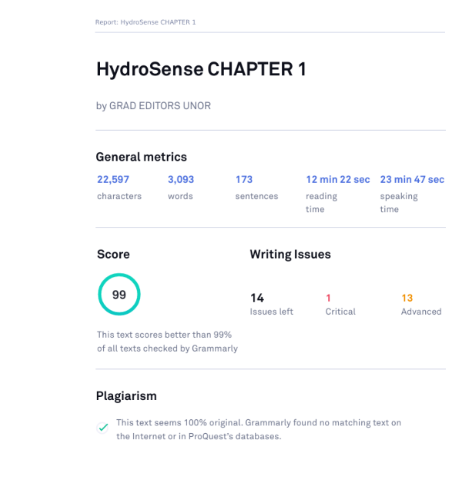
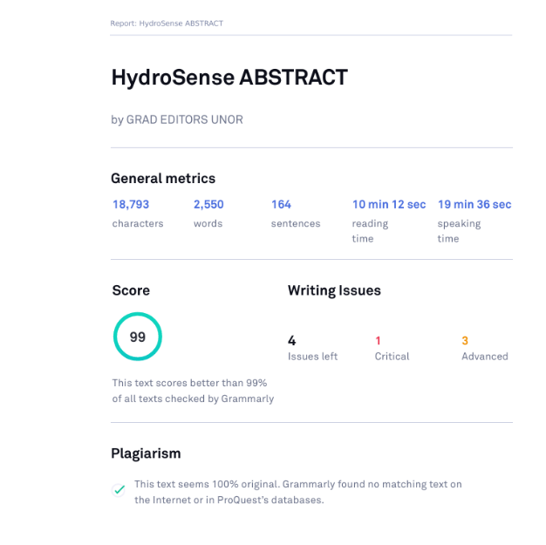

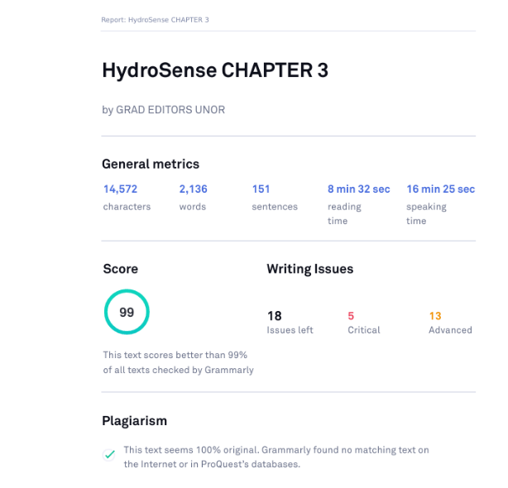
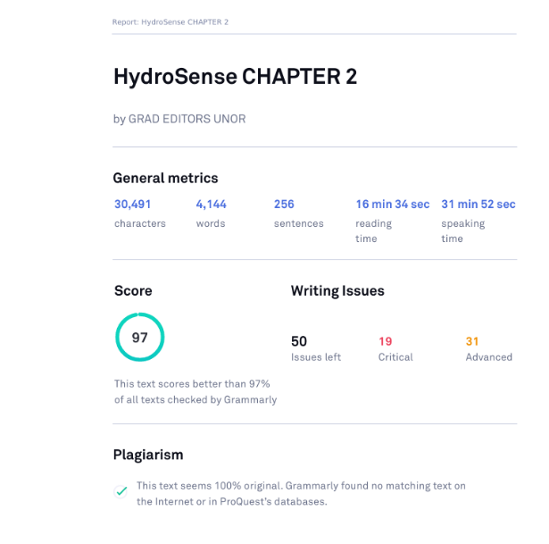

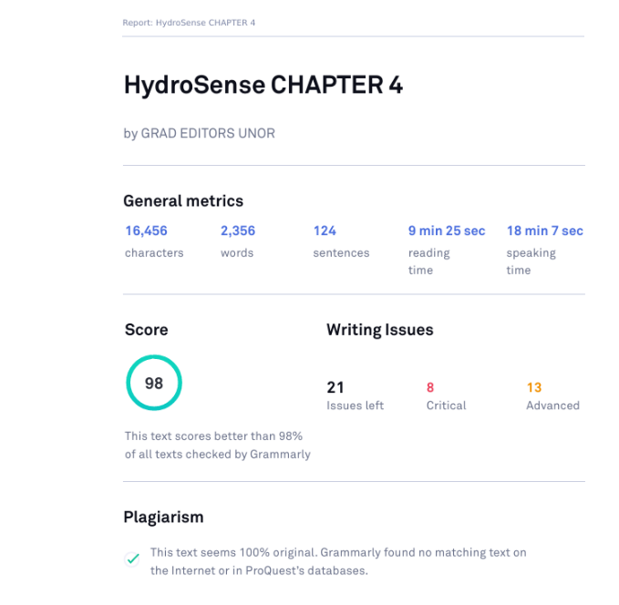
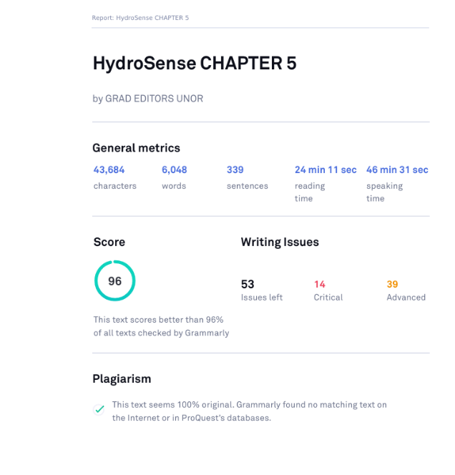
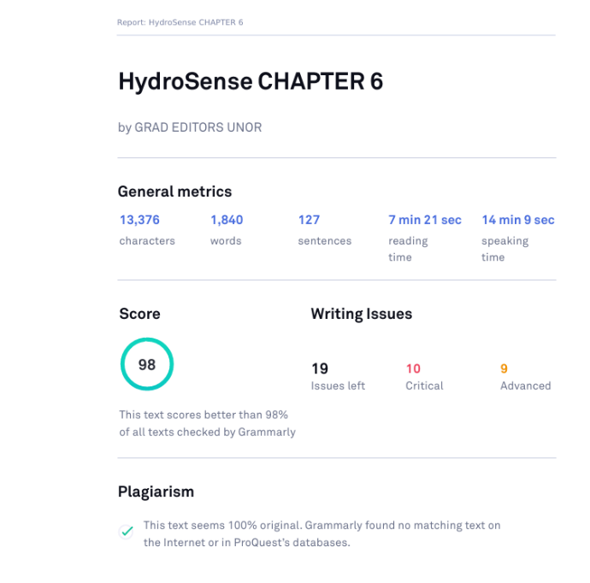
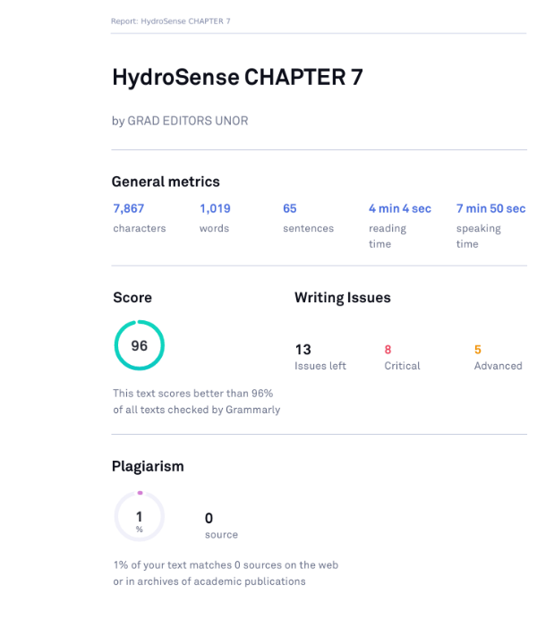

APPENDIX P
Turnitin Results.

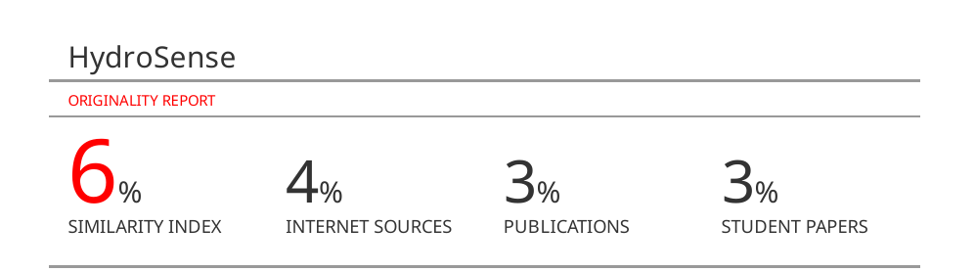
APPENDIX Q
Water Safety Sources in Hydrology Resources.

Source | Type | Title | Link
YouTube | Video | When is water safe to drink? | https://www.youtube.com/watch?v=G244Q4AGJ7U
World Health Organization (WHO) | Guide | Guidelines for drinking-water quality | https://www.who.int/publications/i/item/9789240045064
World Health Organization (WHO) | Article | Drinking-water | https://www.who.int/news-room/fact-sheets/detail/drinking-water
IntechOpen | Book | Safe Drinking Water: Concepts, Benefits, Principles and Standards | https://www.intechopen.com/chapters/57345
National Library of Medicine | Book | Water Supply, Sanitation, and Hygiene | https://www.ncbi.nlm.nih.gov/books/NBK525207/

APPENDIX R
pH Level Sources in Hydrology Resources.

Source | Type | Title | Link
YouTube | Video | Acid and Base | Acids, Bases & pH | https://www.youtube.com/watch?v=V5MqcL9Bck
DataStream | Guide | Physical & Chemical Characteristics (pH) | https://datastream.org/en-ca/guidebook/ph
MedicalNewsToday | Article | The pH of water: What to know | https://www.medicalnewstoday.com/articles/327185
Wastewater Digest | Article | What is pH? | https://www.wwdmag.com/what-is-articles/article/10940015/what-is-ph
ScienceNewsExplores | Article | Scientists Say: pH | https://www.snexplores.org/article/scientists-say-ph

APPENDIX S
Turbidity Level Sources in Hydrology Resources.

Source | Type | Title | Link
YouTube | Video | What Is Turbidity In Water? 6 Things You Should Know | https://www.youtube.com/watch?v=vuFweYh8VRI
HELCOM | Guide | Guidelines for monitoring of turbidity | https://helcom.fi/wp-content/uploads/2019/08/Guidelines-for-measuring-turbidity.pdf
Wastewater Digest | Article | What is Turbidity? | https://www.wwdmag.com/what-is-articles/article/10939754/what-is-turbidity
United States Geological Survey | Article | Turbidity and Water | https://www.usgs.gov/special-topics/water-science-school/science/turbidity-and-water
International Association of Dredging Companies | Articles | Turbidity | https://www.iadc-dredging.com/subject/environment/turbidity/

APPENDIX T
TDS Level Sources in Hydrology Resources.

Source | Type | Title | Link
YouTube | Video | Best bottled water pH TDS test | https://www.youtube.com/watch?v=D5jvCN6FqOs
Kent Health Care Products | Guide | What are Total Dissolved Solids (TDS) & How to Reduce Them? | https://www.kent.co.in/blog/what-are-total-dissolved-solids-tds-how-to-reduce-them/
Safe Drinking Water Foundation | Article | TDS and pH | https://www.safewater.org/fact-sheets-1/2017/1/23/tds-and-ph
ResearchGate | Study | A Study on the Total Dissolved Solids and Hardness Level of Drinking Mineral Water in Bangladesh | https://www.researchgate.net/publication/313103314_A_Study_on_the_Total_Dissolved_Solids_and_Hardness_Level_of_Drinking_Mineral_Water_in_Bangladesh
Fresh Water Systems | Blog | What Is TDS in Water & Why Should You Measure It? | https://www.freshwatersystems.com/blogs/blog/what-is-tds-in-water-why-should-you-measure-it

APPENDIX U
Water Temperature Sources in Hydrology Resources.

Source | Type | Title | Link
YouTube | Video | MEASURE THE TEMPERATURE OF WATER WHEN IT’S HEATED, BOILING AND COOLING | https://www.youtube.com/watch?v=lLSfLMZHVGw
Safe Drinking Water Foundation | Article | WATER TEMPERATURE FACT SHEET | https://www.safewater.org/fact-sheets-1/2018/8/15/water-temperature-fact-sheet
National Library of Medicine | Book | The effect of water temperature and voluntary drinking on the post rehydration sweating | https://pmc.ncbi.nlm.nih.gov/articles/PMC3762624/
United States Geological Survey | Article | Temperature and Water | https://www.usgs.gov/special-topics/water-science-school/science/temperature-and-water
Multidisciplinary Digital Publishing Institute | Article | Drinking Water Temperature around the Globe | https://www.mdpi.com/2073-4441/12/4/1049

APPENDIX V
Filtration Sources in Hydrology Resources.

Source | Type | Title | Link
YouTube | Video | Determine Water Quality using Arduino and Turbidity Sensor | https://www.youtube.com/watch?v=MytUqOz5vbY
YouTube | Video | Filtration Testing & Piloting Guidelines | https://www.youtube.com/watch?v=h_aTYKtBSvw
ScienceDirect | Article | Water Filtration | https://www.sciencedirect.com/topics/chemical-engineering/water-filtration
ScienceDirect | Article | Filtration Process | https://www.sciencedirect.com/topics/engineering/filtration-process
National Library on Medicine | Book | Effectiveness of Membrane Filtration to Improve Drinking Water | https://pmc.ncbi.nlm.nih.gov/articles/PMC5094238/

APPENDIX W
Aeration Sources in Hydrology Resources.

Source | Type | Title | Link
YouTube | Video | Water aeration principle | https://www.youtube.com/watch?v=uLOZblR1VyY
University of Massachusetts Amherst | Article | Aeration Treatment of Drinking Water Supplies | https://ag.umass.edu/cafe/fact-sheets/aeration-treatment-of-drinking-water-supplies#:~:text=Aeration%20treatment%20consists%20of%20passing,to%20volatilize%20into%20the%20air.
National Library on Medicine | Book | Field Research on Mixing Aeration in a Drinking Water Reservoir | https://pmc.ncbi.nlm.nih.gov/articles/PMC6862099/
Wastewater Digest | Article | What is Aeration for Wastewater Treatment? | https://www.wwdmag.com/what-is-articles/article/10939130/what-is-aeration-for-wastewater-treatment
Solitude Lake Management | Article | Oxygenate Your Waterbody with Aeration | https://www.solitudelakemanagement.com/top-3-aeration-articles/

APPENDIX X
Water Distillation Sources in Hydrology Resources.

Source | Type | Title | Link
How to Make Distilled Water | Video | How to Make Distilled Water | https://www.youtube.com/watch?v=VHZitT0-fCY
University of Nebraska–Lincoln | Book | Drinking Water Treatment: Distillation | https://extensionpubs.unl.edu/publication/g1493/2013/pdf/view/g1493-2013.pdf
MedicalNewsToday | Article | Is distilled water safe to drink? | https://www.medicalnewstoday.com/articles/317698
Wastewater Digest | Article | What is Water Distillation? | https://www.wwdmag.com/what-is-articles/article/10940138/what-is-water-distillation
IWA Publishing | Article | Distillation Treatment and Removal of Contaminants from Drinking Water | https://web.archive.org/web/20240625080557/https://www.iwapublishing.com/news/distillation-treatment-and-removal-contaminants-drinking-water

APPENDIX Y
Sedimentation Sources in Hydrology Resources.

Source | Type | Title | Link
YouTube | Video | Sedimentation | https://www.youtube.com/watch?v=YQ2kIXaRNWE
Etch2o | Guide | 2023 Guide to Sedimentation in Water Treatment | https://www.etch2o.com/sedimentation-in-water-treatment/
IOPscience | Paper | Increasing the efficiency of sedimentation tanks for drinking water treatment | https://iopscience.iop.org/article/10.1088/1755-1315/1076/1/012049
Taylor & Francis | Paper | Reduction of sedimentation and water turbidity at intakes of drinking water treatment plants | https://www.tandfonline.com/doi/full/10.1080/23570008.2023.2210892
IWA Publishing | Article | Sedimentation Processes | https://web.archive.org/web/20240720121731/https://www.iwapublishing.com/news/sedimentation-processes

APPENDIX Z
Boiling Water Sources in Hydrology Resources.

Source | Type | Title | Link
YouTube | Video | Boiling Water Bubbles, what makes them exactly? What are they made of? | https://www.youtube.com/watch?v=egwCLxxSfwI
CDC | Guide | Boil Water Advisory | https://web.archive.org/web/20240822023550/https://www.cdc.gov/healthywater/emergency/drinking/drinking-water-advisories/boil-water-advisory.html
CDC | Guide | Making Water Safe in an Emergency | https://web.archive.org/web/20240208041305/www.cdc.gov/healthywater/emergency/making-water-safe.html
MedicalNewsToday | Article | What are the benefits of drinking hot water? | https://www.medicalnewstoday.com/articles/319673
YouTube | Video | Boiling Water Bubbles, what makes them exactly? What are they made of? | https://www.youtube.com/watch?v=egwCLxxSfwI

APPENDIX AA
Water Treatment Sources in Hydrology Resources.

Source | Type | Title | Link
YouTube | Video | How Do Water Treatment Plants Work? | https://www.youtube.com/watch?v=0_ZcCqqpS2o
CDC | Guide | A Guide to Drinking Water Treatment and Sanitation for Backcountry and Travel Use | https://web.archive.org/web/20240807060639/https://www.cdc.gov/healthywater/drinking/travel/backcountry_water_treatment.html
ScienceDirect | Articles | Drinking Water Treatment | https://www.sciencedirect.com/topics/earth-and-planetary-sciences/drinking-water-treatment
SafetyCulture | Articles | A Guide to Understanding Water Treatment | https://safetyculture.com/topics/water-treatment/
ScienceDirect | Article | Water Management, Treatment and Environmental Impact | https://www.sciencedirect.com/topics/agricultural-and-biological-sciences/water-treatment

APPENDIX AB
Alkaline Water Sources in Hydrology Resources.

Source | Type | Title | Link
YouTube | Video | How to make Alkaline Water | https://www.youtube.com/watch?v=s7KKost6a34
Distillata | Guide | A Complete Guide to Alkaline Water | https://distillata.com/blog/a-complete-guide-to-alkaline-water/
Healthline | Articles | What Is Alkaline Water, and What Are the Benefits? | https://www.healthline.com/health/food-nutrition/alkaline-water-benefits-risks
National Library of Medicine | Book | Alkaline Water and Longevity | https://pmc.ncbi.nlm.nih.gov/articles/PMC4906185/
MedicalNewsToday | Article | Is alkaline water good for you? | https://www.medicalnewstoday.com/articles/313681

